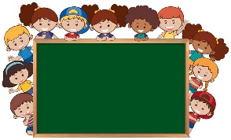

EYFS

Our main theme this term is:

**‘Marvellous me’**

**Our Key Enquiry Questions are:**

How have you changed?

How do we change?

Are we all the same?

What makes us different?

How can we help each other?

This term in our **personal, social and emotional development and learning**, we will be focusing on settling the children into school, encouraging new friendships and learning to dress and undress independently for PE. We will also be using **‘The Colour Monster’** story to look at our own feelings and emotions.

In our **literacy** work, we will be introducing phase 2 phonics, where the children will learn the first phonic sounds and use these to blend and segment words. The children will also focus on recognising and writing their own name, as well as words in pre-cursive.

Our **mathematics** work will focus on matching, sorting and comparing. We will talk about measures and patterns before exploring knowledge of numbers to five. We will also focus on shapes with up to four sides.

Through our **understanding of the world**, we will explore our families and how each family is different. We will look at how we have changed since being a baby and celebrate what we can do now. We will also learn about where we live and our local area of Bolton-le-Sands Village and how our surroundings change throughout the seasons.

Our theme for **RE** this half term will focus on ‘I am special’, Harvest and ‘Special people’ where we will explore what makes people special and how Jesus was special.

**How can I help at home?**

Practise with your child putting on and zipping up their coat independently, and getting themselves dressed in a morning, especially buttons.

Reading books will be changed on Mondays, Wednesdays and Fridays, if you have completed the book. Please spend time each evening reading with your child and return their book along with your comments in their **Reading Record**.

Please don’t throw me away…….

We are always busy creating and planning exciting projects. Please help us out by not throwing away any of these items, we just ask that they are clean. If you come across anything else that might be useful please let us know!

*Bottle tops, kitchen roll tubes, ribbon, scraps of material, interesting packaging, flowers – even ones that are past their best, egg boxes, cardboard boxes, buttons, conkers, pine cones, plastic bottles etc.*

Don’t forget to check your child’s **phonic book** for the new sounds learnt each week. You can practise writing words that contain the sound, draw pictures or just spot the new sounds in your reading book.

Parents – don’t forget to join us for our curriculum evening on Wednesday 27 September at 6pm. The main focus of this will be phonics.

If you have any concerns or would like to discuss any aspect of your child’s progress, please do not hesitate to contact us.

Many thanks for your continued support.

Mrs Beck, Mrs Metcalfe and Mrs Tattersall

Welcome to the autumn term edition of the Curriculum Newsletter.

This term, the key concepts that we will focus on are: **change, family, friendship, love, happiness, fear and community.**

**Bolton-le-Sands C of E Primary School**

**CURRICULUM NEWSLETTER**

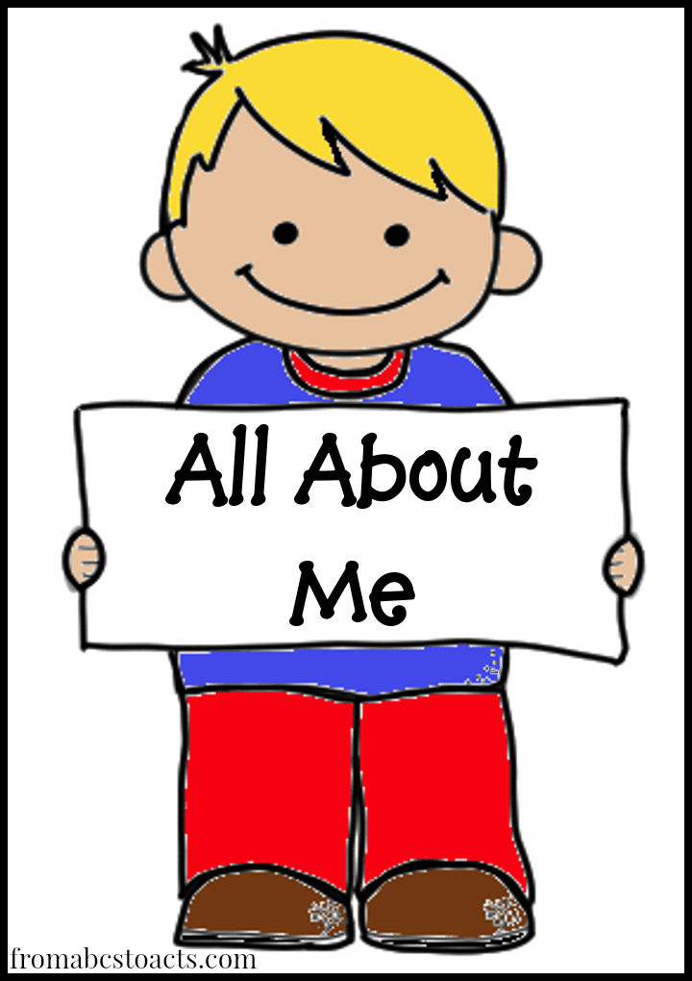

**Marvellous me**

